SAMPLE CONTEST PROGRAM

International Speech And Table Topcs Contest
ARINC Speakeasy Club

DATE: 21 Jan 2009 (Wednesday)
ARINC Building 6
2551 Riva Road
Annapolis MD 21401
6:00 pm - 9:00 pm

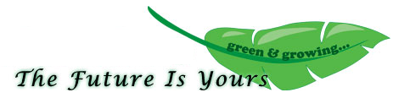
District 18
2008 - 2009
PROGRAM

5:30 PM | Registration and Briefings
6:00 PM | Call To Order
 | Pledge of Allegiance
 | Invocation
 | Welcome
6:10 PM | Table Topics Contest
 | Contestants
7:00 PM | Break
7:15 PM | International Speech Contest
 | Contestants
8:00 PM | Announcements
 | Presentation of Awards
 | Adjourn

Humorous Speech And Evaluation Contest
ARINC Speakeasy Club

DATE: 16 Sep 2009 (Wednesday)
ARINC Building 6
2551 Riva Road
Annapolis MD 21401
6:00 pm - 9:00 pm

District 18
2008 - 2009
PROGRAM

5:30 PM | Registration and Briefings
6:00 PM | Call To Order
 | Pledge of Allegiance
 | Invocation
 | Welcome
6:10 PM | Evaluation Contest
 | Model Speaker Speech
 | Contestants
7:00 PM | Break
7:15 PM | Humorous Speech Contest
 | Contestants
8:00 PM | Announcements
 | Presentation of Awards
 | Adjourn

